Biographies

Michele Godin, MSN, RN, NPD-BC 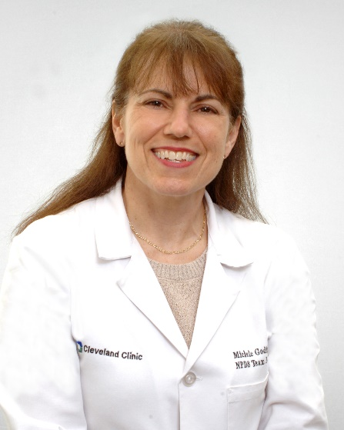
Michele started at the Cleveland Clinic in Weston 15 years ago as a Nursing Professional Development Specialist. She has been in nursing education for over 20 years. She is a master’s prepared nurse (MSN- education) and has obtained her Nursing Professional Development Specialist (NPDS) certification in March 2018. She is mainly responsible to oversee the educational needs of the ambulatory care services. She is also the AHA training site coordinator for the Cleveland Clinic Weston. Furthermore, in 2018 she has started an NPD affiliate in the South Florida region and served as the president until 2021, and secretary from 2022-2024.
In her NPDS role, she teaches several classes (VARN, Preceptor Foundation, medication administration in ambulatory care settings), she is the nursing associate extern program coordinator, and she helps in any capacity she is needed, whether is it to help in nursing orientation, nursing residency, competency validation, etc. Furthermore, she runs interdisciplinary mock codes in the hospital & and satellite offices, consult with nurses, and creates online modules as needed. She has coordinated several new product implementations. She is also a preceptor for her department. She is a member of the Code Blue Committee, the Professional Development Council, the product committee, the Group for Aspiring Leaders, and Global Simulation Advisory Board.
In her free time, she likes to travel, read, ride her motorcycle, paddleboard, and enjoy quality time with friends and family. She goes to her hometown Quebec annually to visit her family.

Ahuby M. González, DNP, RN, NE-BC, NPD-BC 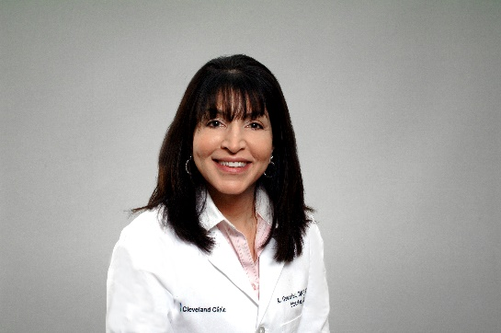
Director, Nursing Education & Professional Development
Cleveland Clinic Weston
Ahuby Gonzalez has been the Director of Nursing Education and Professional Development at Cleveland Clinic Weston since 2016. In her role, she manages a small, extremely talented, and dedicated team of Professional Development Specialists. She has been a nurse for over 19 years. She is Doctoral degree prepared and Board Certified as a Nursing Professional Development Specialist and Nurse Executive. Ahuby supports the expansion of simulation as an instructional method because it provides adult learners with fully immersive educational experiences. When she’s not working, Ahuby is a self-described health enthusiast who enjoys exercising and time with her family.

Aarti Sharma, MSN, RN, NPD-BC 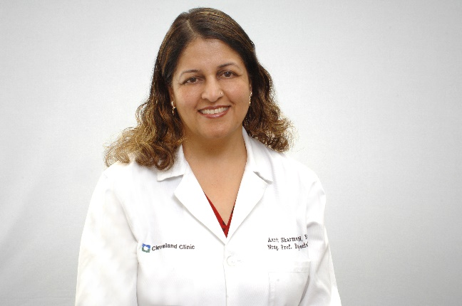

Nursing Professional Development Specialist
Nursing Orientation & Nurse Residency Site Coordinator
Staff Development & Clinical Informatics
Cleveland Clinic Weston,
Aarti Sharma has been a Nursing Professional Development Specialist at Cleveland Clinic Weston since 2018. In her role, she teaches many classes and facilitates Nursing Orientation and the ANCC Practice Transition Accreditation Program (PTAP) Nurse Residency Program. She has been a nurse for over 30 years. She is Master’s degree prepared and Board Certified as a Nursing Professional Development Specialist. Aarti enjoys creating and facilitating Simulation scenarios. When she’s not working, she enjoys time in her garden and with her family.

